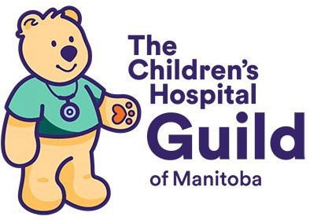 | CHILDREN'S HOSPITAL GUILD OF MANITOBA, INC.  715 McDermot Ave, Winnipeg, MB R3E 1M6  Telephone: (204) 594-5323  Website: https://childrenshospitalguildmanitoba.ca/en/
Guild Membership Form
Name

Home address
Email Address
Phone Numbers | Home: | Cell:

Guild activities you would like to participate in:
☐ Nearly New Shop | ☐ Sew4Kids |  | ☐ Social Committee |  | ☐ Social Media Communication
☐ Fundraising events |  | ☐ Fashion Show |  | ☐ High Tea
How did you learn about the Children’s Hospital Guild?

Annual Guild Membership Fee of $25.00 is due January 31st of each year. Payment may be made by cheque or e-transfer.

*Cheques should be written to: Children's Hospital Guild of Manitoba, Inc. Mail cheque and membership form to: Ilene Holmes, 710 Cloutier Drive, Winnipeg, MB R3V 1A8
*E-Transfers to: childrenshospitalguildofmb@gmail.com. Please include your name and reason for payment. Send completed MEMBERSHIP FORM to Ilene Holmes at the above address.

WITHDRAWAL from the Guild: Please notify the Guild Secretary

*I give permission for my contact information to appear on the Membership Roster.
☐ Yes__________ ☐ No____________

Signature: | Date:

PAID: Cheque ______ Cash __________ E-transfer __________ Date_________

